**Project 6: Geometric Modeling**

**Screenshots**

1. **Model having animated eyes and mouth, and stationary face, nose and moustache**

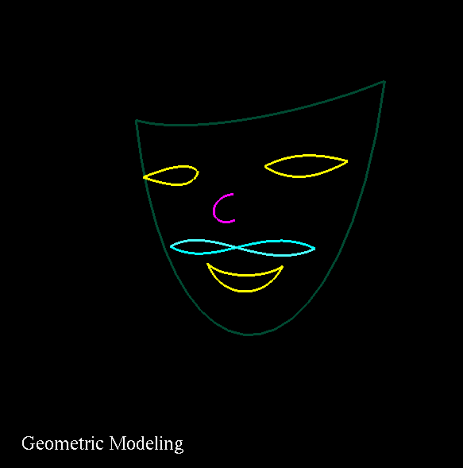

**2) Control Points**

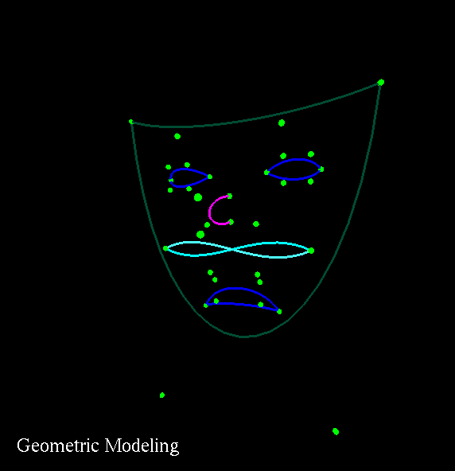

**3) Control Lines**

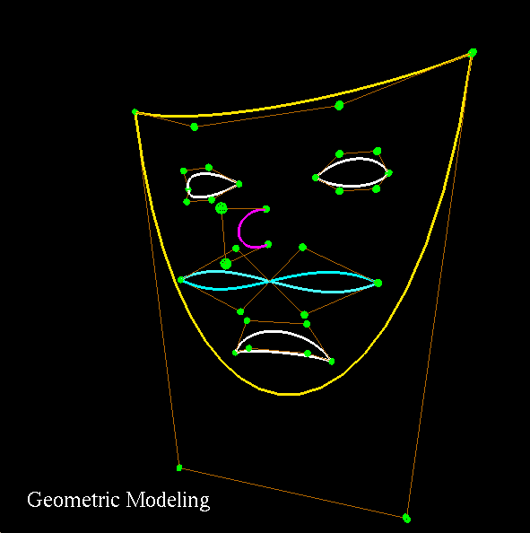

**Youtube Video Link:**

<https://youtu.be/Avys9IyaMkI>